**Data Analytics Bootcamp : Project 1(World Happiness Report) Findings and Analysis**

**Presented by**: Team Gamma

**Team Members**: Poalo E. Vazquez,

Georgina Guzman Rasillo

Harpreet Kaur

Santiagi Velz

**Submitted to**: Jose Manuel Barrera

**Submitted on:** November 03, 2020

**Introduction and the Purpose of the Project**

The Project 1 presented by Team Gamma is about the “*World Happiness report*”. The primary report was distributed in 2012 with subsequent reports published from time to time. This paper is a write-up summarizing our major findings from the study. We analyzed the impact of various socio-economic factors on the happiness score of various countries around the globe for the years 2019 and 2020.

**Questions and our Analysis**

Below are the questions we aim to answer in the project and the analysis of our findings along with the graphic presentation:

1) **The Top 5 happiest countries in terms of the Happiness score in 2019 and 2020**

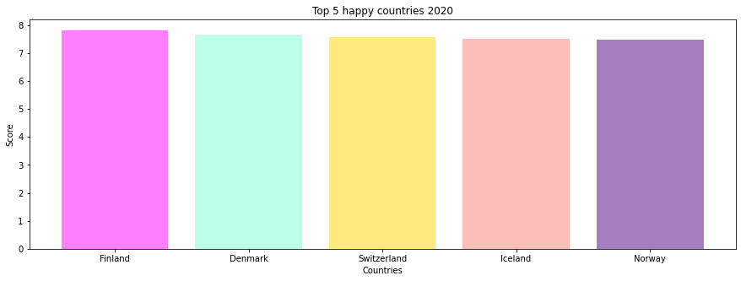

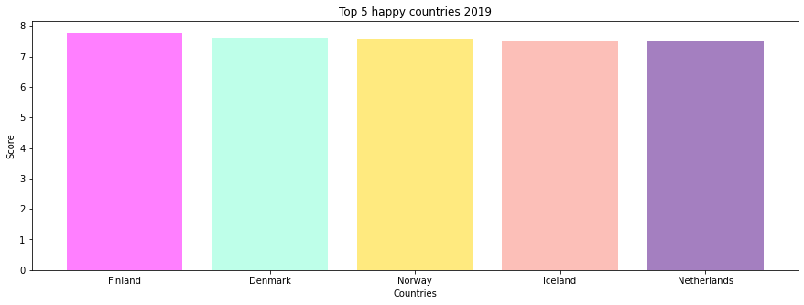

**Analysis** – The above two graphs shows that there hasn’t been much difference in the happy countries from 2019 to 2020. The charts are topped by Finland, followed by Denmark in both the years. Switzerland took over Norway as the third happy country in 2020, whereas Norway still being in the top five dropped to the fifth position. Seems like Iceland is not ready to give up its fourth position as the happy country for both years.

**2) The Last 5 happiest countries in terms of the Happiness score in 2019 and 2020**

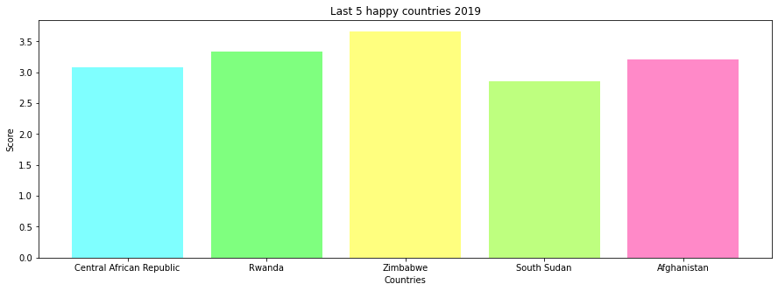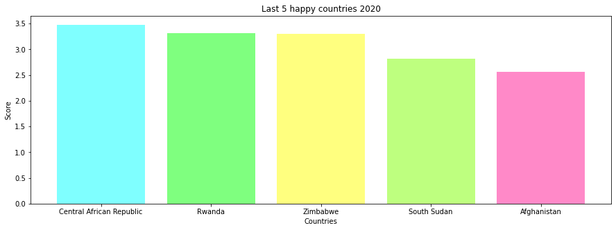

**Analysis** – Surprisingly there is no change in the last 5 happy countries in the world for the years 2019 and 2020. Seems like nothing much has changed in these five countries that might have made their people happier.

**3) Changes/ Comparison in the happiness score for Mexico in 2019 and 2020**

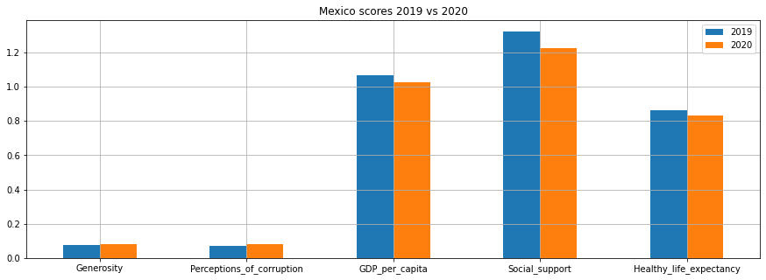

**Analysis** – Analyzing the happiness score factors for Mexico for 2019 and 2020 does not bring any alarming signals. As suspected, due to COVID-19 the GDP per Capita, Social Support and healthy life expectancy has been impacted negatively. There has been an increase in the perception of corruption as most of the authorities are busy in combating the effects of Coronavirus. Even in the time of need people might not be able to show much generosity as the pandemic has taken all the close contacts away from people.

**4) Factors impacting the happiness score for Mexico for the year 2020**

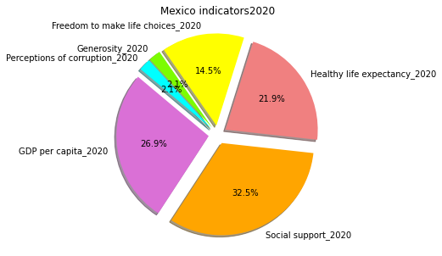

**Analysis –** As per the pie chart above social support has the highest impact on the happiness score for Mexico in the year 2020, followed by GDP per Capita, Healthy life expectancy, freedom to make life choices, Generosity, and Perceptions of corruption.

**5) The healthy life expectancy changes from 2019 to 2020**

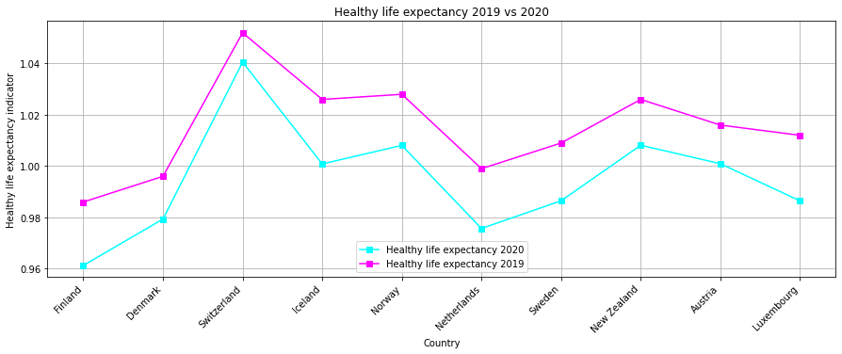

**Analysis** – The healthy life expectancy seems to decrease for all of the top ten countries from 2019 to 2020 as COVID-19 spread into a pandemic and slowed our lives to a great extent.

**6) The correlation between GDP per Capita and Happiness score for 2019 and 2020**

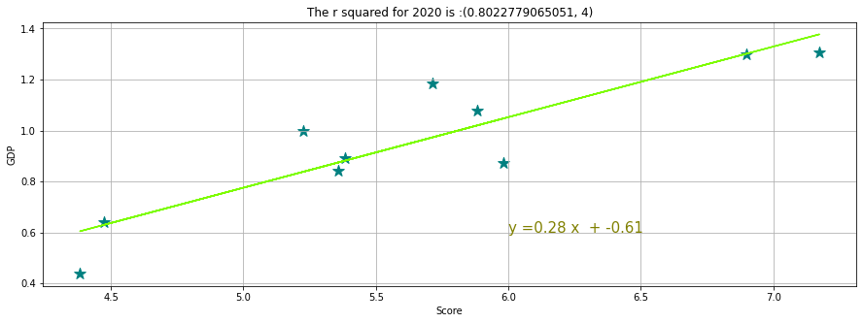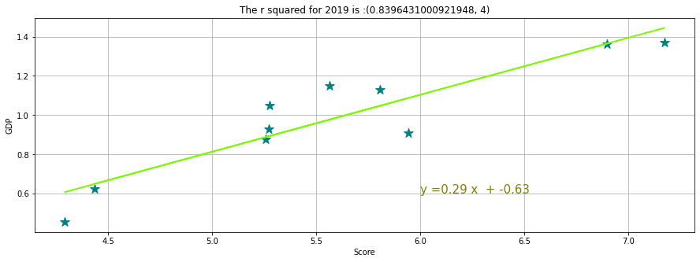

**Analysis** – We analyzed the correlation between GDP per Capita and Happiness score for both years 2019 and 2020 to see the relationship between the relative movements of two variables. We used Pearson correlation to analyze the relationship. The r-squared for both years is greater than 0.7, which shows a strong positive correlation between GDP and happiness score. As the GDP per Capita increases in the various regions of the world, the corresponding happiness score also increase.

References

<https://www.kaggle.com/mathurinache/world-happiness-report>

Jupyter notebook (20201017), Working with Weather & City APIs

Jupyter notebook (20201013), Introduction to Statistics